**HQ Site**

**Domain Controller 1: HQ-DC01**

Uses: Windows Server 2022

Roles: Active Directory

Authoritative DNS for Int.Elections.bc.ca

Authoritative DHCP (Load-Balanced)

Location: 326-012 POD 1 (Bottom-Row 4th)

Switch: External

Ipv4: 10.10.20.1

RAM: 16GB

Storage: 714GB

**Domain Controller 2: HQ-DC02**

Uses: Windows Server 2022

Roles: Active Directory

Secondary DNS For int.elections.bc.ca

Authoritative DHCP (Load-Balanced)

Location: (326-011 POD 1 Bottom-Row 3rd)

Switch: External

Ipv4: 10.10.20.2

RAM: 16GB

Storage: 714GB

**Lamp Server: HQ-LAMP01**

Uses: Ubuntu Server 22.04 LTS

Roles: Inside DMZ

Location: (326-09 POD 1 Bottom-Row 2nd)

Switch: External

Ipv4: 192.168.1.6

**Domain File Services (DFS01): HQ-DFS01**

Uses: Windows Server 2022

Roles: DFS Namespaces

DFS Replication

Location: 326-010 POD 1 (Bottom 4th)

Ipv4: 10.10.20.4

**Domain File Services (DFS02): HQ-DFS02**

Uses: Windows Server 2022

Roles: DFS Namespaces

DFS Replication

Location: 326-011 POD 1 (Bottom-Row 3rd)

Switch: External

Ipv4: 10.10.20.5

**Headquarters Firewall: HQ-FW01**

Uses: Pfsense VM

Roles: Windows 10

Location: 326-009 POD 1 (Bottom-1st)

Switch: External, External 2

Ipv4: 10.1.114.109, 192.168.1.10

192.168.1.5

**Voting Site Firewall: VS1-FW01**

Uses: Pfsense VM

Roles: Windows 10

Location: 326-005 POD 2 (Top 1st)

Switch: External, External 2

Ipv4: 10.1.115.9, 10.20.10.254

**Phone Server: HQPS01**

Uses: Debian

Roles: Phones

Location 326-0010 POD 1 (Bottom 2nd)

Switch: External

Ipv4: 10.10.10.1

**WorkStation: HQ-WS01**

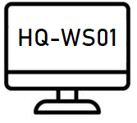Uses: Windows 10

Roles: N/A

Location 326-008 POD 2

Switch: External

Ipv4: DHCP

RAM: 4098MB

Storage: 127GB

**WorkStation: HQ-WS02**

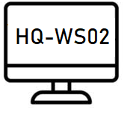Uses: Windows 10

Roles: N/A

Location 326-008 POD 2

Switch: External

Ipv4: DHCP

**WorkStation: HQ-WS03**

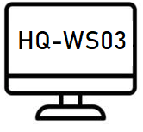Uses: Windows 10

Roles: N/A

Location 326-007 POD 2

Switch: External

Ipv4: DHCP

**WorkStation: HQ-WS04**

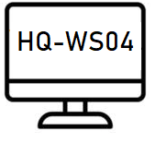Uses: Windows 10

Roles: N/A

Location 326-007 POD 2

Switch: External

Ipv4: DHCP

**Voting Station: VS-vs01**

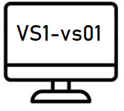Uses: Windows 10

Roles: N/A

Location 326-005 POD 1

Switch: External

Ipv4: DHCP

**Voting Station: VS-vs02**

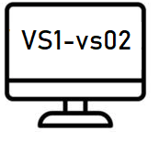Uses: Windows 10

Roles: N/A

Location 326-005

Switch: External

Ipv4: DHCP

**Voting Station: VS01-DHCP**

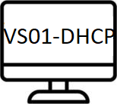Uses: Windows 10

Roles: N/A

Location 326-007 POD 2

Switch: External

Ipv4: DHCP